Screen report – Spanish (Chile)

Device: eDiary - HTC HD2

Created from: WPAI+CIQ Asthma_Spanish_Chile_Final_13154_05August2013.xlsx Version 1, 07Aug2013

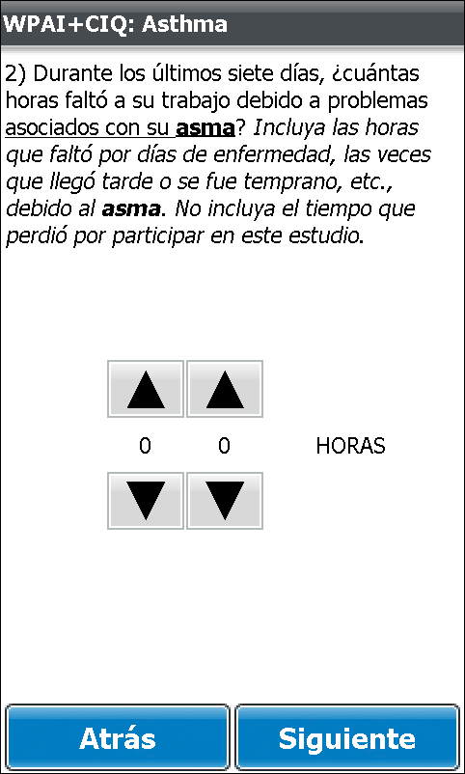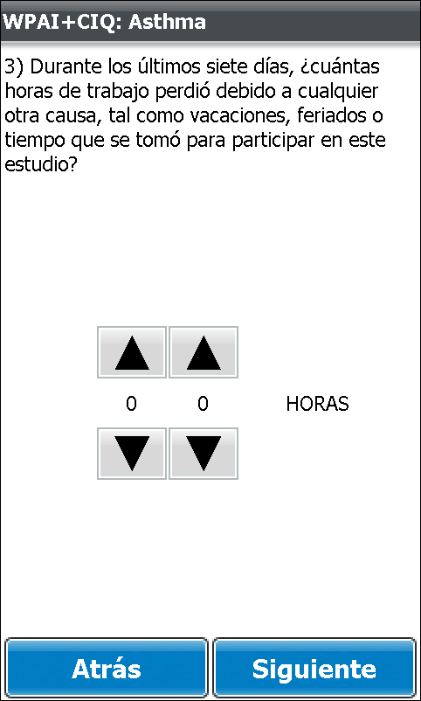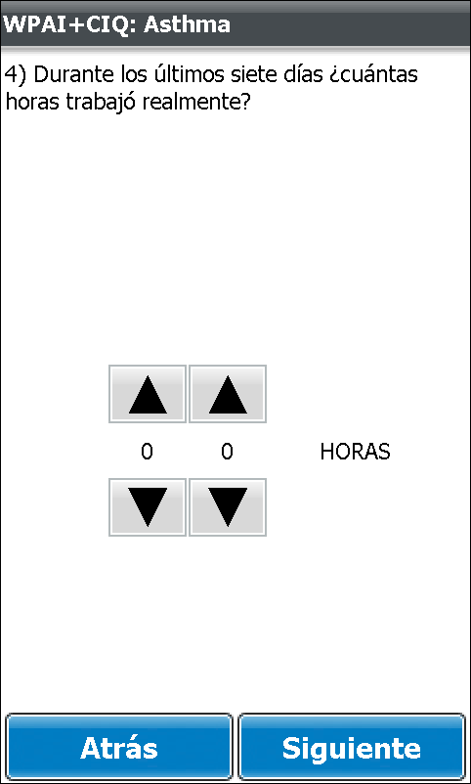

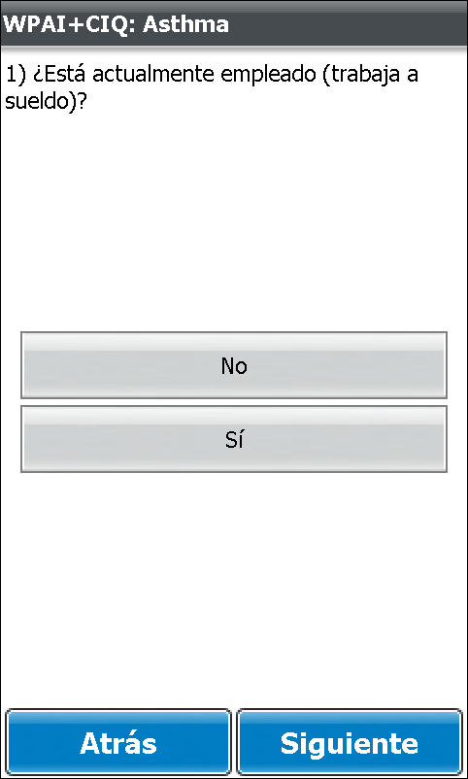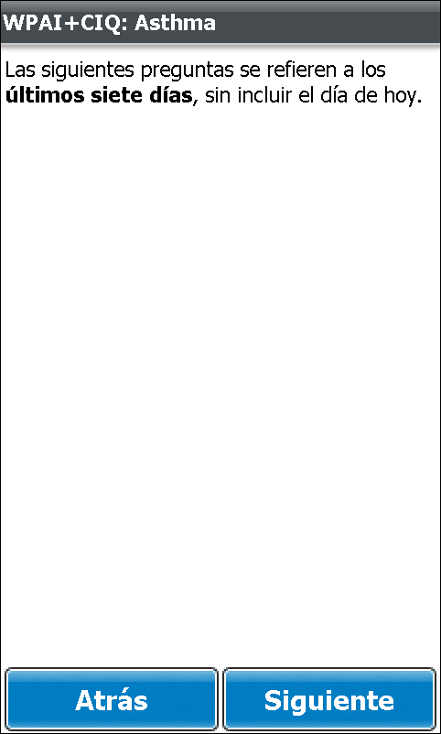**1 Form: WPAI+CIQ:Asthma**

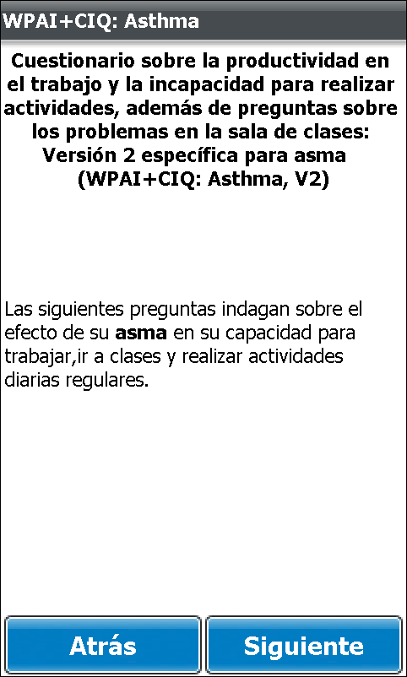

|  |  |  |
| --- | --- | --- |
| Screen 1 | Screen 2 | Screen 3 |
| Screen 4 | Screen 5 | Screen 6 |

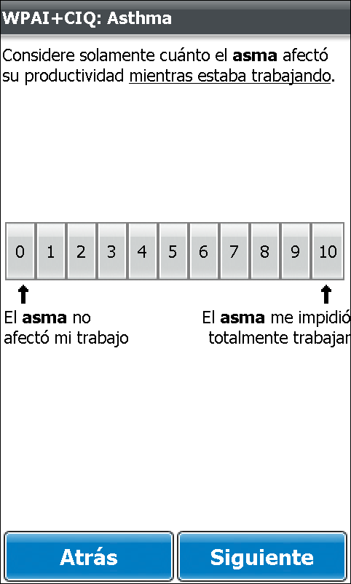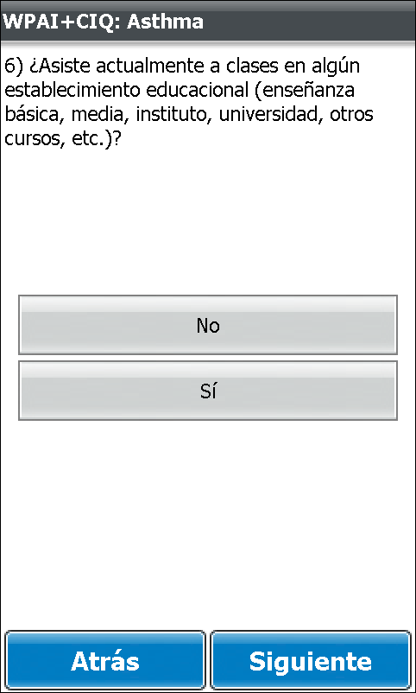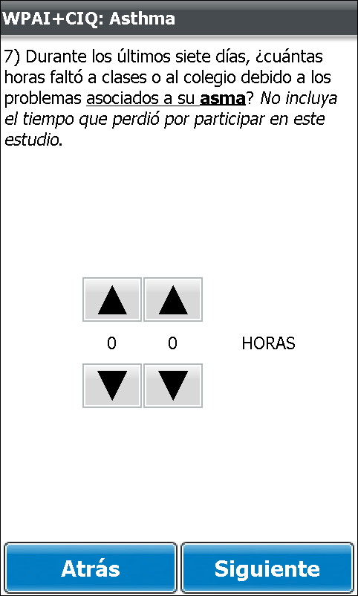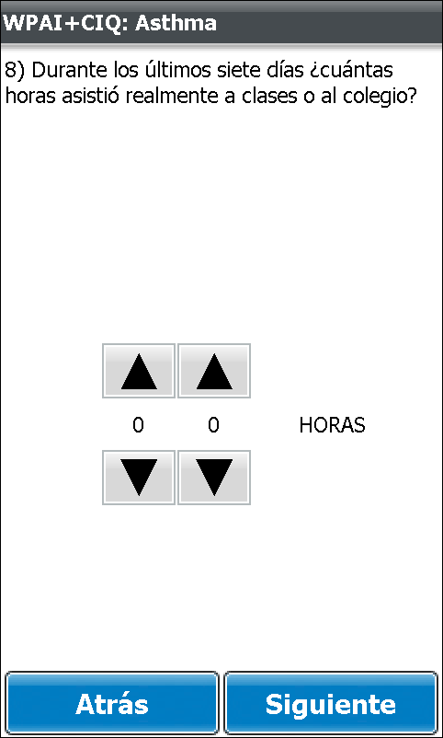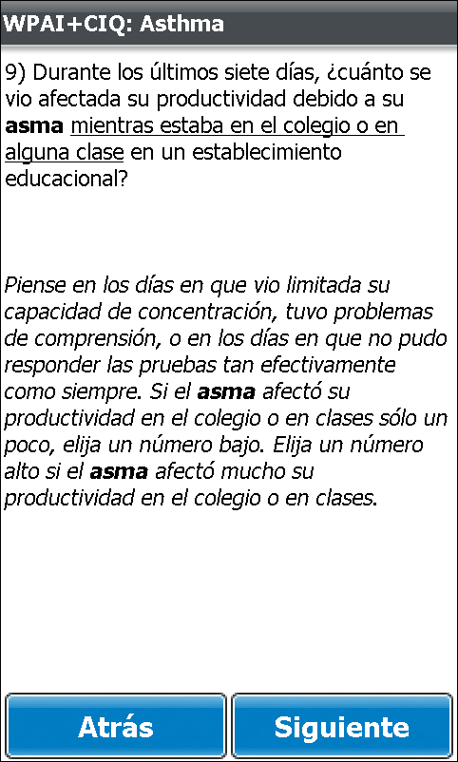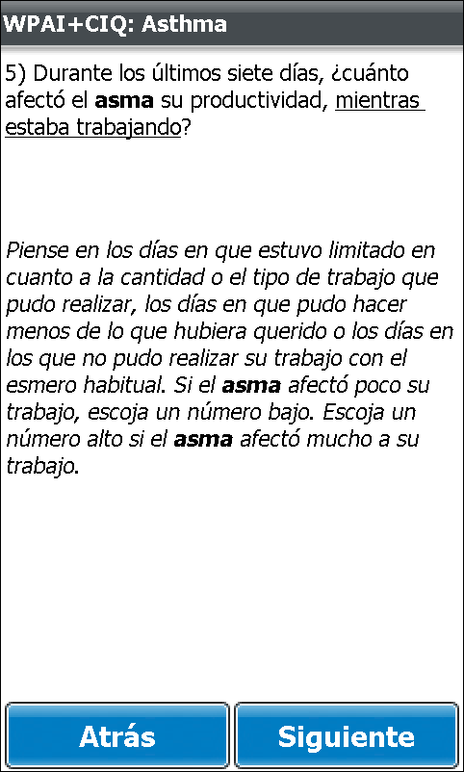

|  |  |  |
| --- | --- | --- |
| Screen 7 | Screen 8 | Screen 9 |
| Screen 10 | Screen 11 | Screen 12 |

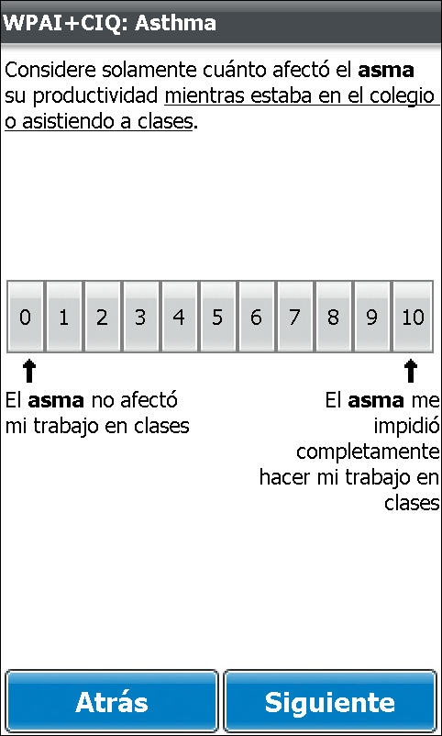

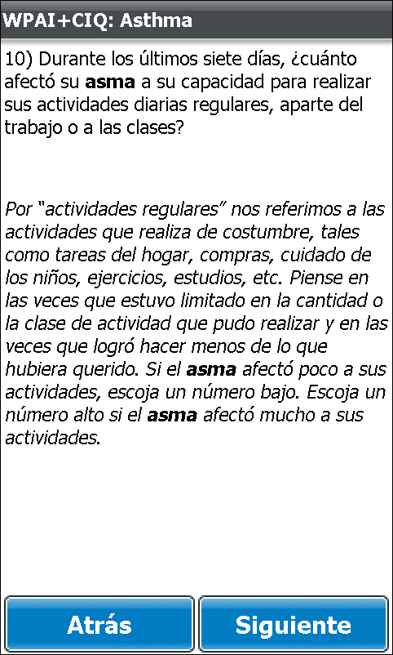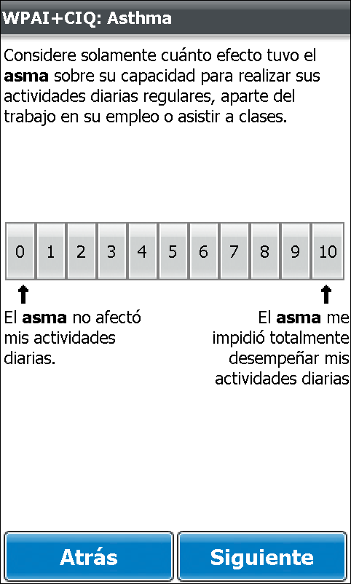Screen 13 Screen 14 Screen 15